Assignment 3RD

WRC078BEI048

1. Simulate DHCP server on packet tracer also track DHCP packets on your local network using Wireshark.

-> a.Launch Wireshark and select your network interface.

b.Click the Start button (shark fin icon) to begin capturing packets.

c.Type ipconfig/release in the cmd to display only DHCP packets.

d. Look for DHCP Discover, Offer, Request, and ACK packets.

e.Click the Stop button (red square icon) and save the capture if needed.

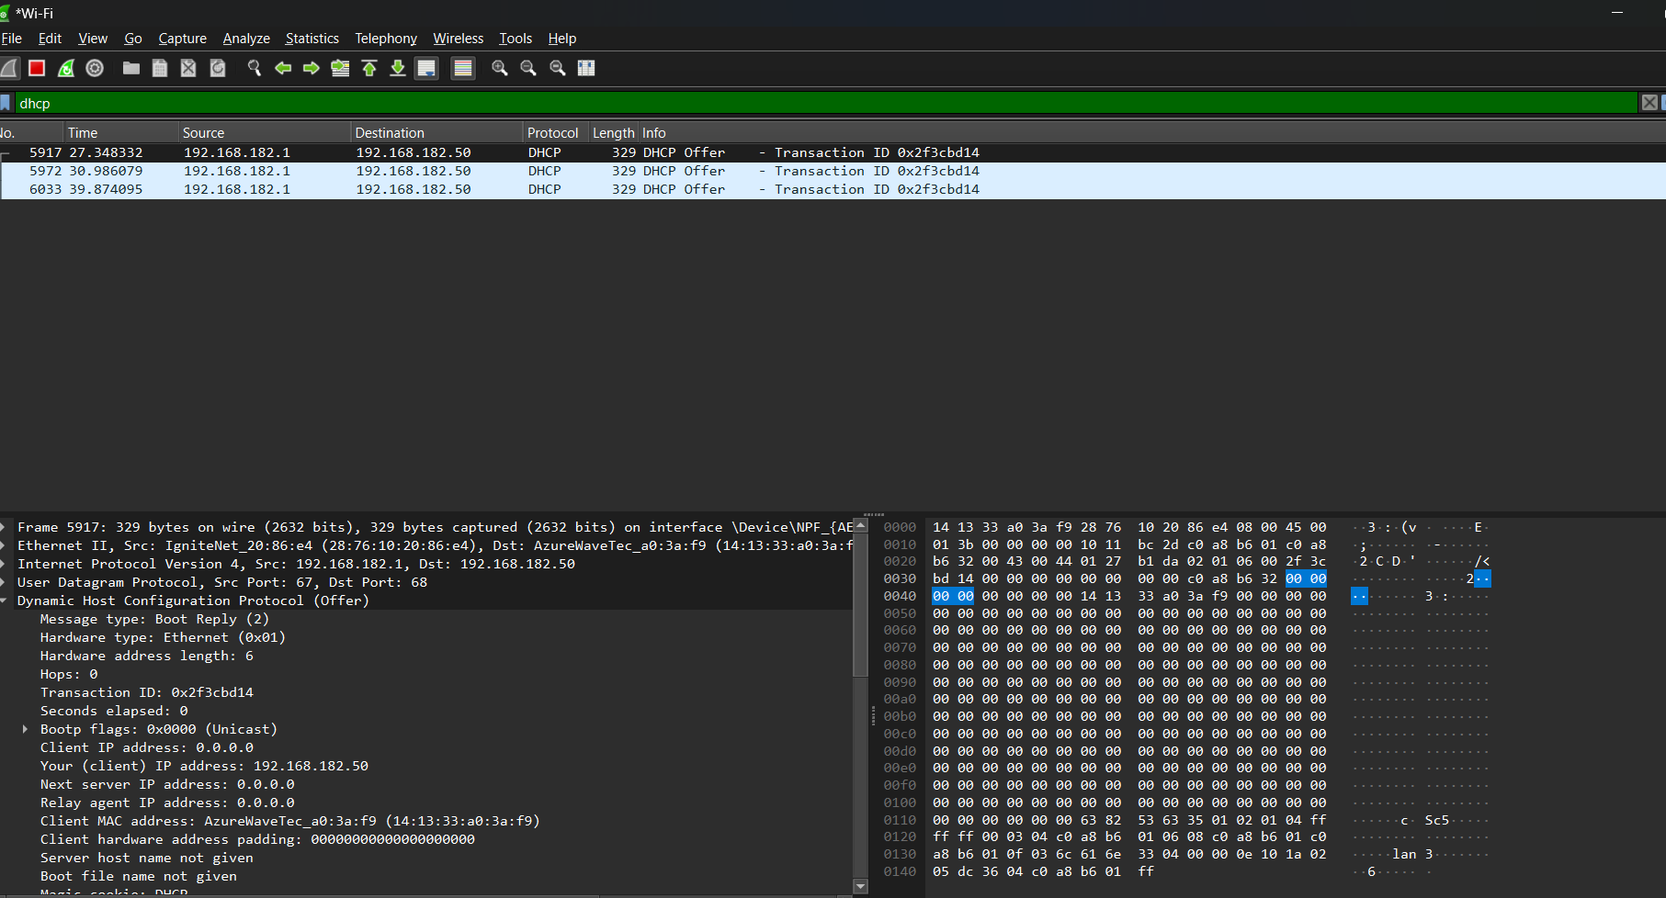

~real-time DHCP traffic and each packet’s details

Q. What happens when you type *facebook.com* and enter?

-> a .You enter a URL into a web browser.

b. Browser looks up DNS server for the IP address for a given domain name (i.e. *facebook.com* IP address translation).

c. Browser sends Http request to the server.

d. Server sends Http response to the browser.

e. Browser begins rendering the html.

f. Browser sends requests for additional objects embedded in html (Images, CSS, JavaScript) and repeat steps c-e.

Once the page is loaded the browser sends further async requests as needed.

Reference: <https://youtu.be/uyvEa7Nh80A?si=UPk4l6VdRTlm4UxY>